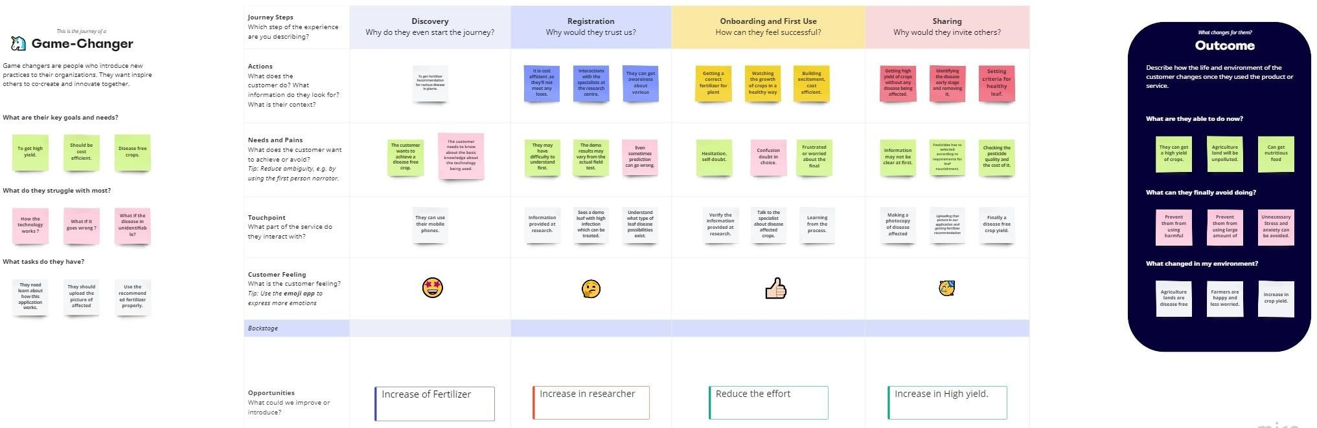Team ID: PNT2022TMID31070 Project: Fertilizers Recommendation System for Disease Prediction Date: 27 October 2022